Appendix 1

# APPLICATION FOR MEMBERSHIP OF

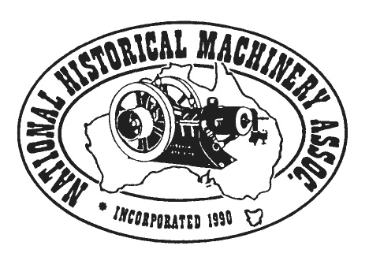**THE NATIONAL HISTORICAL MACHINERY ASSOCIATION INCORPORATED**

ABN: 12 908 216 532 Inc. No. A0020801V

**Applicant:**

**………………………………………………………………………………….., of ………………………………………………………………………..**

**[name of applicant club] [postal address]**

**Contact email: ............................................ Contact Phone: ...........................................**

**desires to become a member of National Historical Machinery Association Inc.**

**In the event of the club’s admission as a member, we agree to be bound by the rules of the Association for the time being in force.**

**…………………………………………………………. Date ……………………………….**

**Signature of Secretary**

Please Provide a Brief List of your club's Activities:

......................................................................................................................................................................................................................

......................................................................................................................................................................................................................

**Your Club requires two NHMA Inc. Member clubs to nominate and second the application.**

**Nominating Member Club:**

……………………………………………………………………………………………………………………………………….. , a member of the Association.

[name of club]

**Nominate the applicant for membership of the Association.**

……………………………………………………. ........................................................ Date: ...................................

[Please Print, Secretary's Name] [Signature of Secretary]

**Seconding Member Club:**

………………………………………………………………………………………………………, a member of the Association, and not being the nominating club.

[name of club]

**Second the nomination of the applicant for membership of the Association.**

………………………………………………………….. .......................................................... Date: ................................

[Please Print, Secretary's Name] [Signature of Seconder]

**PLEASE FILL THIS FORM OUT AND RETURN TO: NHMA ,**  **PO Box 2024, IDALIA, QLD 4811**